BDSH Foremost Report – L0_Graphic.dd

This is an example report for a network analysis from a team member of BDSH and does not include any AI analysis.
Contents
Summary report 1

Summary report
This report contains the analysis of the L0_Graphic.dd file which contains Three images of undescribed importance.

Present filetypes
The file that contains the information we are after is the L0_Graphic.dd file which we have extracted to provide us with the following filetypes; JPG, GIF and PNG. Respectively the files contained in this dd file are 00056902.jpg, 00126243.gif and 00010000.png.
From what we can see in the images, the first image, 00056902.jpg (figure #1) is representative of a sign for those states “Welcome to Moscow” it is associated with two smaller signs with one stating “University of Idaho” and another stating “Home of Moscow High School | Bears”, At this time, it is unclear what the forensic significance of this image is within this forensic investigation.
Furthermore, the second image, 00126243.gif (figure #2) shows what appears to be a broken image of a sunflower, though this appears to also be a gif we can only see a almost corrupted version of this file. Once again, it is unclear the forensic significance of this image.
The third image, 00010000.png (figure #3) provides us with an image of flower of undescribed significance, it is unclear what the forensic significance of this image is.
Furthermore, a reverse image search provided no further information for any of the provided images/figures

Files

Figure #1 - 00056902.jpg
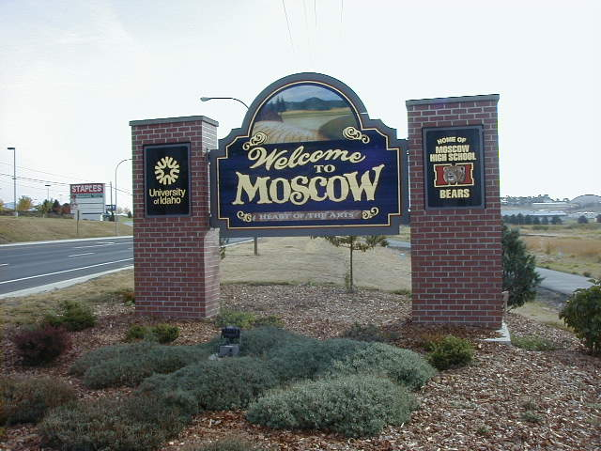

Figure #2 - 00126243.gif


Figure #3 - 00010000.png


This report took me about 30 minutes to create

